Ideation Phase
Empathize & Discover

Date | 29 January 2026
Team ID | SWTID-2026-7933
Project Name | AI FAQ Assistant
Maximum Marks | 4 Marks

AI FAQ Assistant – Empathy Map Canvas
An empathy map is a simple, easy-to-digest visual that captures knowledge about a user’s behaviors and attitudes.
It helps the project team understand how users search for answers and what they expect from an automated assistant. Creating an effective solution requires understanding the true problem and the person experiencing it. The exercise of creating the map helps participants consider things from the user’s perspective along with their goals and challenges.
Target User: A customer, employee, or site visitor who needs fast, accurate, and instant answers to common questions without waiting for human support.
AI FAQ Assistant User Empathy Map:

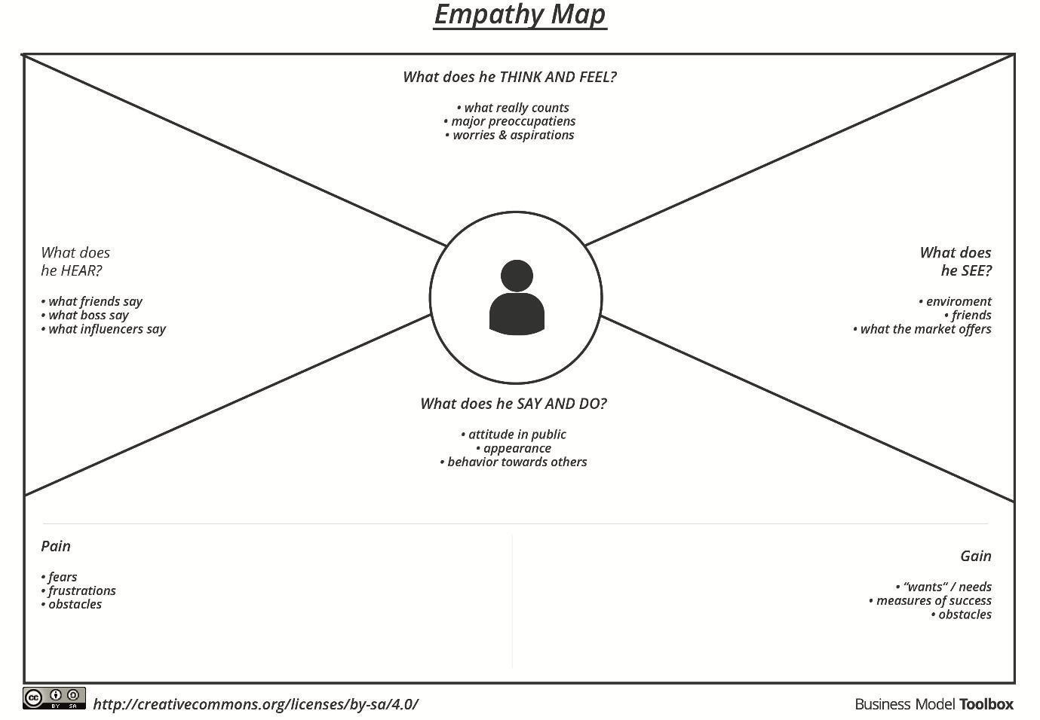

AI FAQ Assistant User: A person who needs instant, accurate, and easy-to-understand answers to their queries without waiting for human support.

AI FAQ Assistant – User Empathy Map: Automated Customer Support & Knowledge Base Application
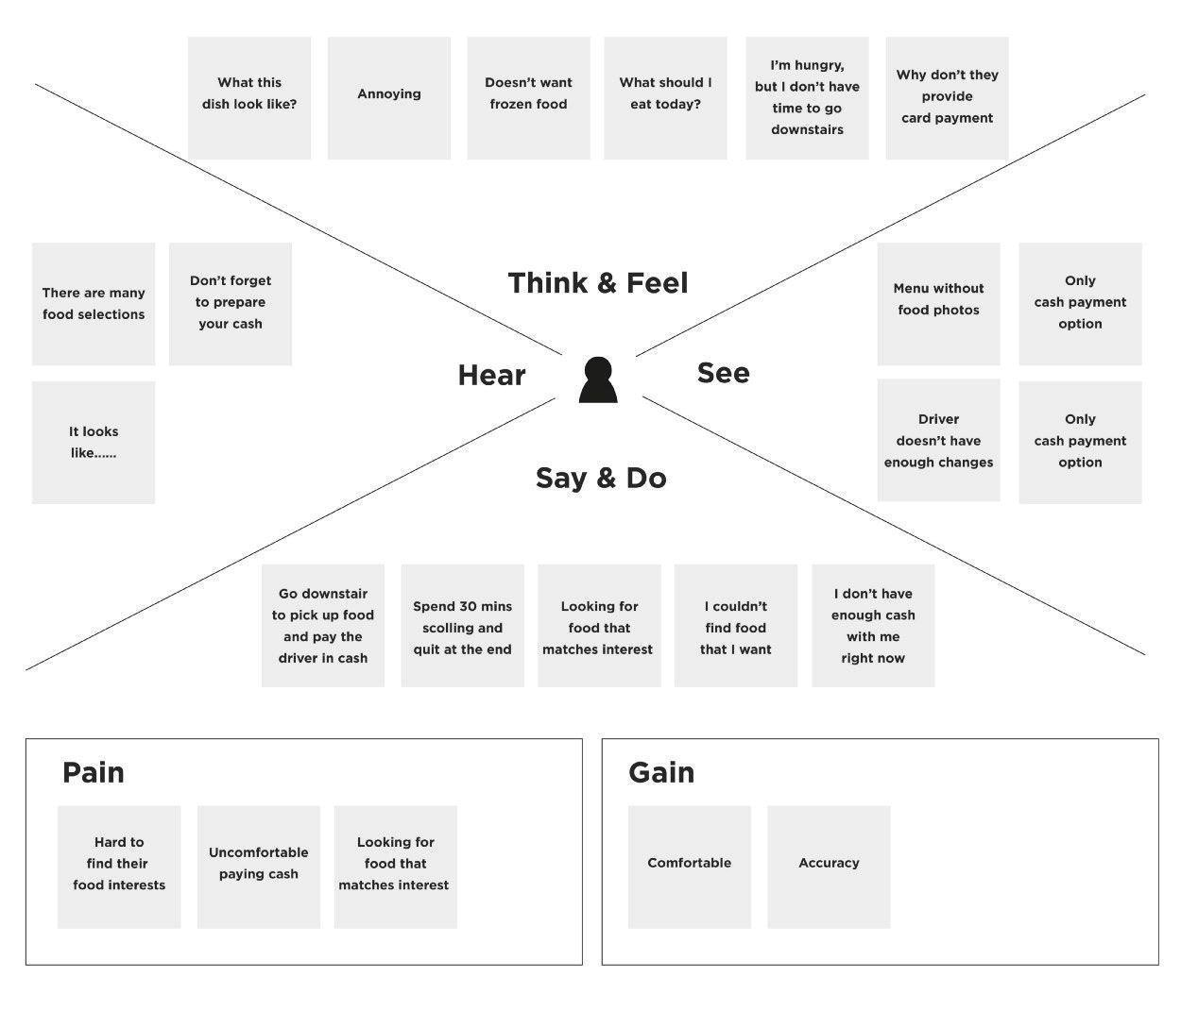AI FAQ Assistant-User Empathy Map

Says
“I need a quick answer to my question right now.”
“I don't want to wait on hold or wait days for an email reply.”
“Is there a simple way to find this policy or detail?”

Thinks
“Will this AI actually understand what I'm asking, or will it give me random links?”
“Can I trust the information provided by this bot?”
“Is it going to transfer me to a real person if it gets stuck?”

Does
Types conversational questions into the chat box or search bar.
Tries different rephrasings if the first attempt fails.
Scans responses quickly for key facts, links, or action steps.

Feels
Feels relieved when answers are instant, clear, and spot-on.
Feels confident when the assistant cites sources or offers an easy escalation route.
Feels frustrated when stuck in repetitive loops or given irrelevant answers.

Pains
Generic, inaccurate, or outdated responses (hallucinations).
Rigid query matching that fails to understand natural language or context.
Dead-end interactions with no option to speak with a human support agent.

Gains
Instant 24/7 access to accurate information without queue delays.
Clear, concise responses formatted for quick reading.
Seamless escalation to live support when queries are complex.

